Required Components
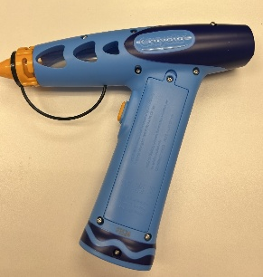 | 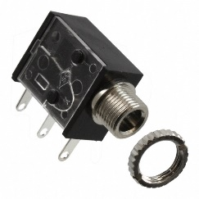 | BOM  - Crayola Marker Airbrush Spray Art Kit (Amazon, Walmart)  - 3.5 mm Mono Jack and Ring  - 22 AWG Wire  - 4 AA Batteries  Refer to the Tool and Component List for purchasing details.
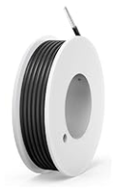 | 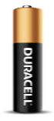

Required Tools
- Triangle Screwdriver
- Small Phillips Screwdriver 3mm Diameter
- Ruler
- Wire strippers
- Soldering iron and solder
- Drill and 1/4” drill bit

Required Personal Protective Equipment (PPE)
- Safety glasses

Assembly Instructions
- Carefully remove the toy from its packaging without damaging it (we will be repackaging the toy after adapting). | 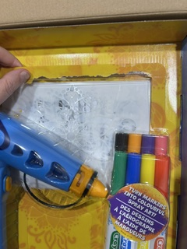
- Locate and remove the 8 screws along the body of the toy, using the triangle screwdriver. Carefully separate the two halves of the toy.  *Note: keep screws, and keep track of where they came from if there are multiple different sized screws | 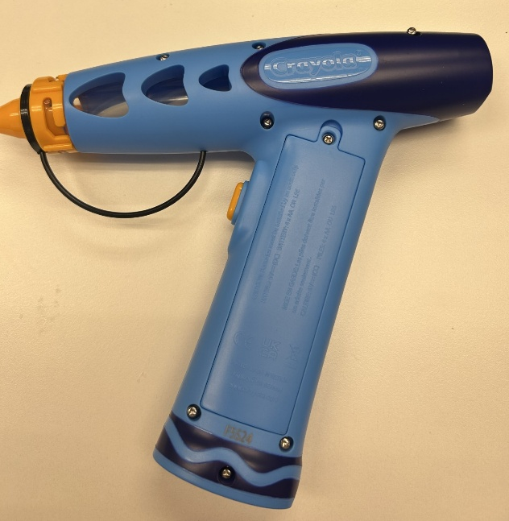
- Cut 2 pieces of wire, each 15 cm long. | 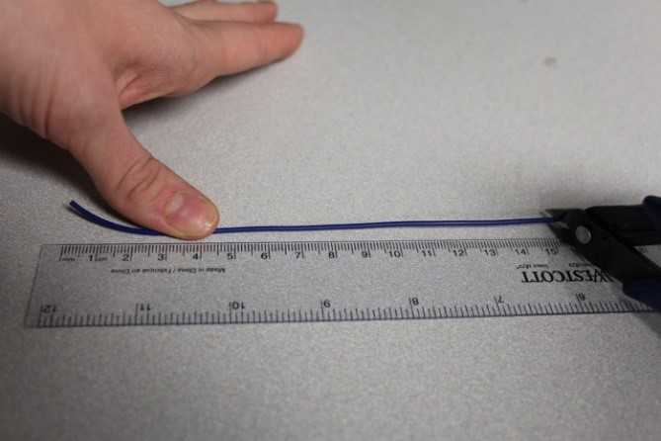
- Use wire strippers to strip approximately 0.5 cm off each end of the wires | 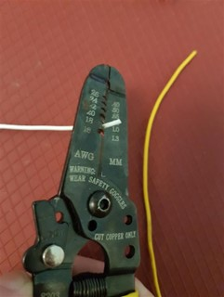
- Solder the two wires onto the front two tabs of the mono jack. | 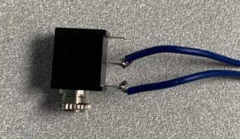
- Tin the other ends of the wires by adding a small amount of solder to each wire. | 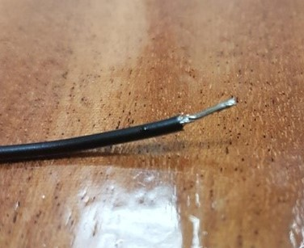
- Solder the first new wire from the mono jack in parallel with the existing wire connected to the switch. Do this by carefully soldering the new wire on top of the existing wire that goes to the switch, being careful not to break the original connection. | 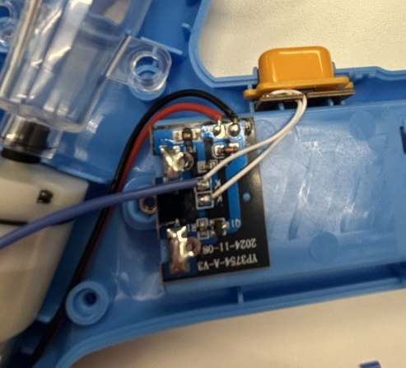
- Solder the second wire from the mono jack in parallel with the existing wire. Do this by carefully soldering the new wire on top of the existing wire that goes to the switch, being careful not to break the original connection. | 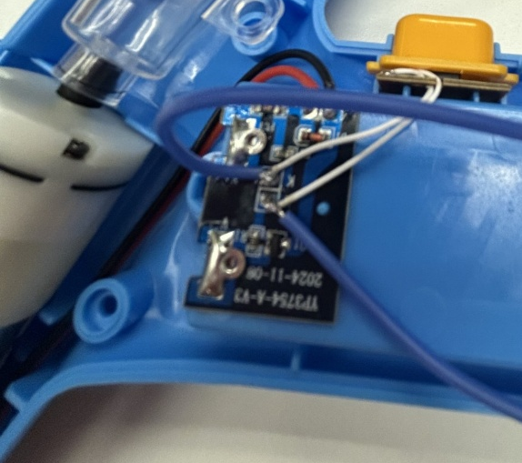
- It is now time to test the toy. Insert batteries into the battery compartment and an assistive switch into the mono jack. Test to make sure that the toy can be controlled using the original switch and the assistive switch.  Notes:  - If the toy does not turn on, please check the soldered connections.  - If the toy continuously sprays, the connection is shorted. Check for areas of touching solder and separate using a soldering iron. | 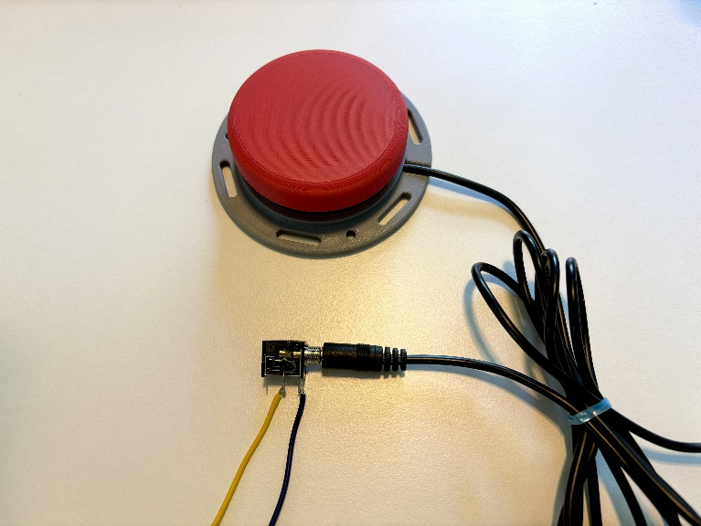
- Using a ¼” drill bit, drill a hole into the position shown on the right. Remove any loose plastic. | 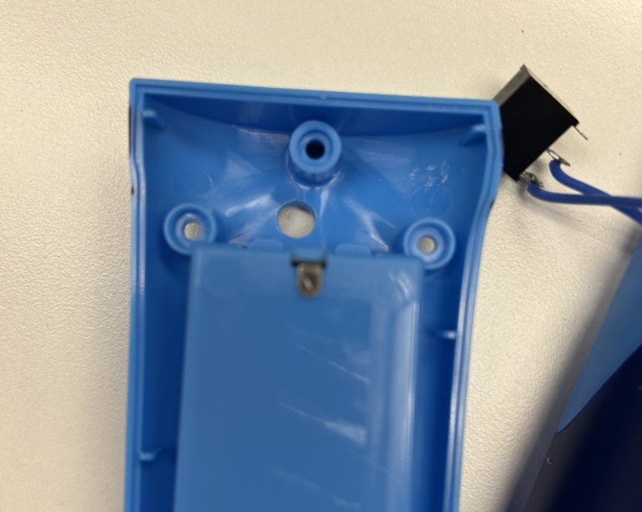
- Remove the retaining ring from the mono jack and push the mono jack through the hole from the inside. Reinstall the retaining ring on the outside of the toy and tighten to secure. | 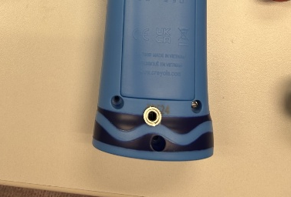
- Start to reassemble the toy, tucking your new wires in along the side of the battery component. | 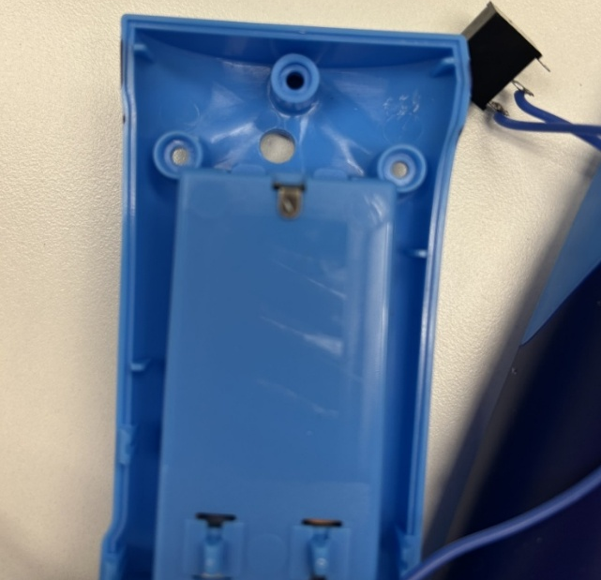
- Reassemble the toy using the screws set aside earlier. | 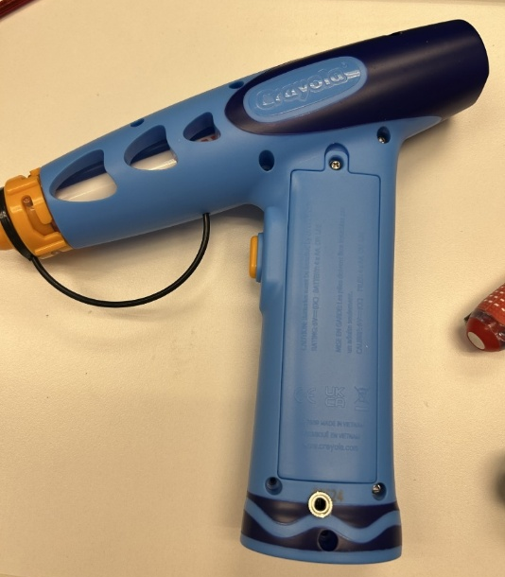
- Test the toy again. If it is still working properly, repackage the toy and the adapted toy is complete! | 